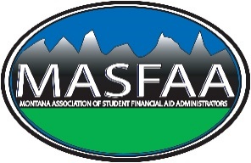
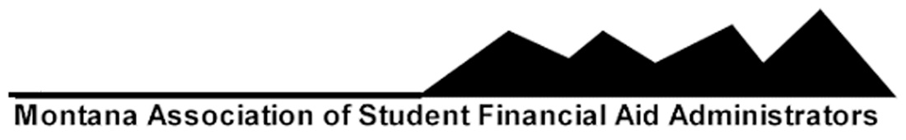
-

MASFAA Business Meeting

Date: Friday, March 23, 2018 / 11:00 AM
Location: Great Falls Holiday Inn

- Call to Order and Establish a quorum
- Approval of Agenda
  - Danielle Dinges, Diane Llewellyn
- Approval of Minutes from April 2017
  - Kelli Engelhardt, Danielle Dinges
- Officers Reports
- President, Cindy Kiefer
  - She had a great and uncomfortable year
  - Winter Board Meeting
    - NASFAA & RMASFAA
  - MASFAA Director’s Meeting
- President Elect – Danielle Dinges
  - DC Visit
- Past President – Emily Williamson
  - Thanks
  - RMASFAA Conference 2019
- Vice President/Secretary – Julie Watson (Emily Williamson)
  - RMASFAA Associate News
    - What’s happening in MT
    - Hidden Talents
- Treasurer – Emily Linn
  - Spring Conference 18 is up
  - Mick Hanson Scholarship – for Leadership Pipeline NOT SI and Minority
    - Need to have application (copy Diversity or RMASFAA Leadership Pipeline app for mentee)
    - Need to have deadline and criteria (same time as other MT scholarships or wait until after mentee application
  - Income and Expense Report
  - Made $580 in last night’s update
- Member-at-Large – Ellen Smith
  - No updates
- Member-at-Large – Diane Llewellyn
  - Logo update (2004)
- Associate Member – Mary Howard
- Committee Reports
- Conference Planning – Kelli Engelhardt, Emily Linn, Sheena Jager
- Nominations – Emily Williamson:
President Elect: Kent McGowan/UofM
Emily Williamson, Cindy Small
Member-at-Large: Justin Beach/MSU Billings
Kelli Engelhardt, Danielle Dinges
- Budget and Audit Committee / Treasurer’s Report – Emily Linn
  - Danielle Dinges and Emily Linn will work on this and get out to association
- Recognition of MASFAA Members serving on current RMASFAA/NASFAA Committees RMASFAA
Summer Institute Committee – James Broscheit
Board of Directors Secretary – Leslie Olson
Board of Directors Montana Representative- Cindy Kiefer
Leadership Pipeline Program Chair- Janet Riis
Leadership Pipeline Committee – Shauna Savage
Leadership Pipeline Mentors – Jessica Francischetti & Kent McGowan
Leadership Pipeline Mentees – Justin Beach & Karina Moulton
Association News Committee – Julie Watson
Diversity and Multicultural Initiatives Committee - Beverly Lammey
Membership – Alexa Freeburg
Membership Committee – Danielle Dinges
Training Committee – Valerie Curtin
Conference 2019 Co-Chairs – Shauna Savage & Emily Williamson
- Old business
  - Free vouchers for credentials will end after SI – Janet Riis
- New Business
  - Joint MACRAO conference discussion
  - Minority SI Scholarship. Application due by April 1, 2018 to assure SI Registration.
  - Election of Officers.
  - Summer Institute Scholarship
    - DCC, UMW, GFC
  - 2018 MASFAA Awards
    - Financial Aid Professional of the Year
    - Years of Service Awards
- Spring 2019 Conference
  - Location will either be Billings or Bozeman
    - Bozeman is next in cycle, but want to determine if we can host at same hotel RMASFAA 2019 will be at in Billings.
    - Emily Williamson and James Broscheit will run respective numbers and submit them to the board for vote.
  - Dates:
    - March 20-22, 2019
- Passing the Gavel
  - Danielle Dinges becomes President
  - Danielle Dinges presented Cindy Kiefer with a plaque thanking her for her service.
- Adjourn
  - 1st Janet Riis, 2nd Cindy Kiefer

